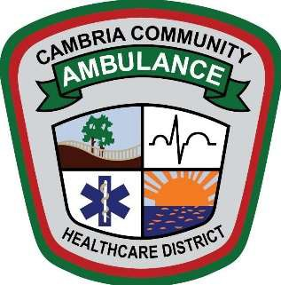

**CAMBRIA COMMUNITY HEALTHCARE DISTRICT**

**SPECIAL BOARD MEETING**

**FEBRUARY 18, 2025 – 9:00 AM**

The special meeting of the Cambria Community Healthcare District will be held via Zoom and the public is welcome to attend at 2535 Main Street, Cambria, California.

**Join Zoom Meeting**

Add Zoom Meeting Link

# AGENDA

## OPENING

* 1. Call to order
  2. Establishment of a quorum

## PUBLIC COMMENT FOR ITEMS NOT ON THE AGENDA

* 1. Public members wishing to address the Board on matters other than scheduled items may do so when recognized by the President of the Board of Directors, Cecilia Montalvo. Presentations are limited to a maximum of three minutes per person.

## REGULAR BUSINESS

* 1. Contract for Owner Advisor Services for the New Ambulance Station

1. **ADJOURNMENT**

The next regular meeting of the Cambria Community Healthcare District Board of Directors will be held on February 25, 2025, at 9:00 A.M. at the Old Cambria Grammar School, 1350 Main Street Cambria, California.

Copies of the monthly agenda, staff reports, and written materials provided to the Board of Directors for Open Session agenda items may be obtained online at www.cambria-healthcare.org and at the District office located at 2511 Main Street, Cambria, during regular business hours. Closed-session items are not available for public review. Any changes or additions to the agenda will be posted at the District office and on the District website.

Note: While board members may not engage in dialog with the public during the board meeting, individual members may choose to incorporate an answer to a question posed by the public during their discussion of an agenda item.